**ROBOT SUMMARY** Group -03 - HELIOS

* **Components**
  + - Robotic car full Plastic Chassis
    - 2 $×$ HC05 Ultrasonic Sensors
    - 3 $×$ IR sensor
    - 9V Battery
    - 12 V 18650 4000mAh rechargeable Battery Pack
    - 4 $×$ Brushed DC Motors with Encoders
    - Motor Controller/ Motor Driver
    - Arduino UNO R3
    - Wires
* **Body Structure**

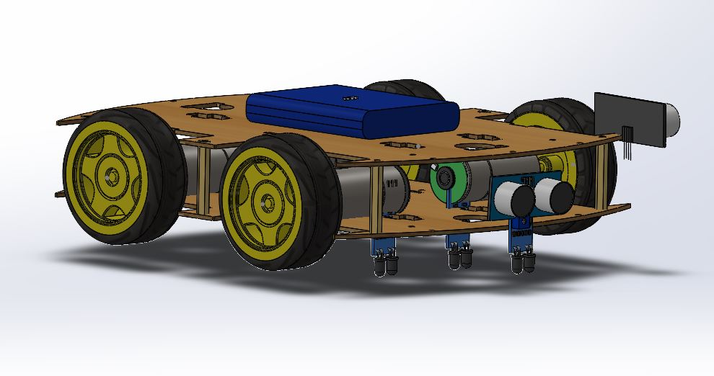

**19cm**

**24cm**

­­­­­

* **Mechanical Design**
  + - The robot main body is made up of plastics and the connectors of both planes are metals.
    - Tires are plastics.
    - Since our whole robot is about 1.2kg in assembly.
    - Size = 28cm $×$ 19cm
    - Weight range 1.2kg to1.5 kg
* **Functionality**
  + - Arduino Uno is the brain of the robot.
    - All sensors and motor encoders are connected with Arduino.
    - Depending on the sensor reading Arduino commands the wheels to complete the task.
    - For example, in line following when left IR sensor detect the white Arduino command right motors to raise the speed and left motors to slow down the speed. As the result robot turn left.
    - Another example, when front ultrasonic Sensor detect obstacles. Arduino delay for a time and do the task according to the algorithm.
* **Algorithm**
  + - **Line following**

Totally three IR sensors are here. One sensor is attached front side middle. And other two are in both sides 4.5cm behind to the front sensor.

**Sensor Decisions**

IF, back left (white) and Right (Black) – Left turning - Turn left

IF, Back Right (White) and Left (Black)- Right turning – Turn Right

IF all three sensors detect white – Start/Stop box – Move Forward

All three detect Black – Line ends – turn 180 degree and do the line following.

Back two (white), front (black)- It is ‘T’ turn - turn left and line follow

Finally, IF the second box detected End the algorithm.

* + - **In the blind box**

robot function left side wall following (7cm gab). When there is a sudden increase length in left ultrasonic sensor(>150cm). Move 25cm forward and turn left 90 degrees. Further move forward and see whether line is detected or not. If detected move forward. If not detected move back to initial position and turn 90 degrees right and do wall following task.

When obstacle detected in the front sensor turn right and do the wall following task. When there is sudden increase in left sensor (<100cm) move 25 cm forward and turn left, move 25cm forward and do wall following task.

Finally, IF the line detected activate the line following algorithm

* **Actuators**
  + - Four Brushed 12V DC motors with encoders for each tire connected with Motor Controller. Using the encoder and tires rotations reading traveled distance can be calculated. This used in maze shortest path solving task.
    - Since our whole robot is about 1.3kg. 12V battery is to power the motors to get enough torque for robot motion.
* **Sensors**
  + - 2 ultrasonic sensors, 4 IR sensors used here.
    - One Ultra sonic sensor for detecting the obstacles front to avoid collision and
    - One Ultra sonic sensor placed left side of the robot for maintain a distance from a wall in wall following task.
    - Four IR sensor Used for line following, maze solving.